Lesson 1: The Pythagorean Theorem

Classwork
Example 1
Write an equation that will allow you to determine the length of the unknown side of the right triangle.
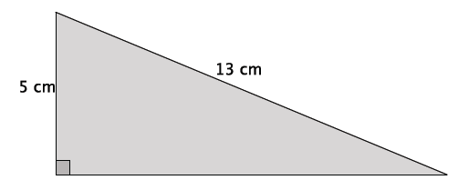

Example 2
Write an equation that will allow you to determine the length of the unknown side of the right triangle.
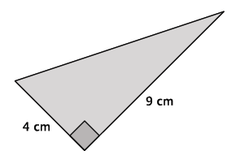

Example 3
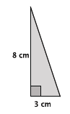
Write an equation to determine the length of the unknown side of the right triangle.
Example 4
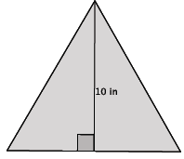
In the figure below, we have an equilateral triangle with a height of 10 inches. What do we know about an equilateral triangle?

Exercises 1–3
- Use the Pythagorean Theorem to estimate the length of the unknown side of the right triangle. Explain why your estimate makes sense.
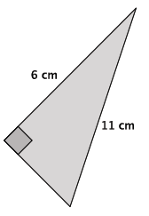

- Use the Pythagorean Theorem to estimate the length of the unknown side of the right triangle. Explain why your estimate makes sense.
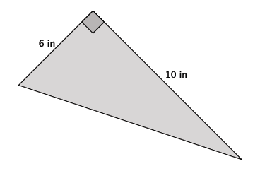

- Use the Pythagorean Theorem to estimate the length of the unknown side of the right triangle. Explain why your estimate makes sense.
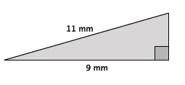

Let $c$ represent the length of the hypotenuse. Then,
$$3^{2}+7^{2}=c^{2} \\ 9+49=c^{2} \\ 58=c^{2}$$
The number $58$ is not a perfect square, but it is between the perfect squares $49$ and $64$. Therefore, the length of the hypotenuse is between $7$and $8$, but closer to $8$ because $58$ is closer to the perfect square $64$ than it is to the perfect square $49$.

Lesson Summary
Perfect square numbers are those that are a product of an integer factor multiplied by itself. For example, the number $25$ is a perfect square number because it is the product of $5$ multiplied by $5.$
When the square of the length of an unknown side of a right triangle is not equal to a perfect square, you can estimate the length by determining which two perfect squares the number is between.
Example:
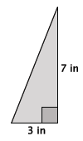

Problem Set

- Use the Pythagorean Theorem to estimate the length of the unknown side of the right triangle. Explain why your estimate makes sense.
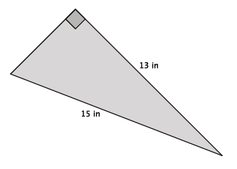

- Use the Pythagorean Theorem to estimate the length of the unknown side of the right triangle. Explain why your estimate makes sense.
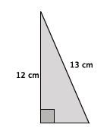
- Use the Pythagorean Theorem to estimate the length of the unknown side of the right triangle. Explain why your estimate makes sense.
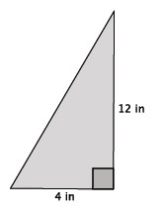

- Use the Pythagorean Theorem to estimate the length of the unknown side of the right triangle. Explain why your estimate makes sense.
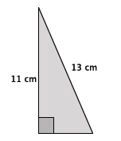

- Use the Pythagorean Theorem to estimate the length of the unknown side of the right triangle. Explain why your estimate makes sense.
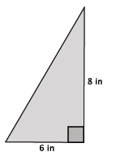
- Determine the length of the unknown side of the right triangle. Explain how you know your answer is correct.
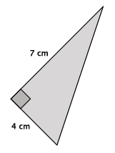

- Use the Pythagorean Theorem to estimate the length of the unknown side of the right triangle. Explain why your estimate makes sense.
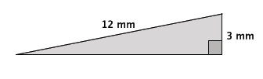

- The triangle below is an isosceles triangle. Use what you know about the Pythagorean Theorem to determine the approximate length of base of the isosceles triangle.
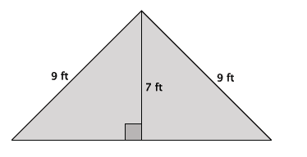

- Give an estimate for the area of the triangle shown below. Explain why it is a good estimate.
