Lesson 2: Square Roots

Classwork
Exercises 1–4
- Determine the positive square root of $81$, if it exists. Explain.

- Determine the positive square root of $225$, if it exists. Explain.

- Determine the positive square root of $-36$, if it exists. Explain.

- Determine the positive square root of$49$, if it exists. Explain.

Discussion
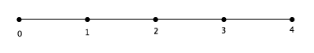

Exercises 5–9
Determine the positive square root of the number given. If the number is not a perfect square, determine which integer the square root would be closest to, then use “guess and check” to give an approximate answer to one or two decimal places.
- $\sqrt{49}$

- $\sqrt{62}$

- $\sqrt{122}$

- $\sqrt{400}$

- Which of the numbers in Exercises 5–8 are not perfect squares? Explain.

Lesson Summary
A positive number whose square is equal to a positive number $b$ is denoted by the symbol $\sqrt{b}$. The symbol $\sqrt{b}$ automatically denotes a positive number. For example, $\sqrt{4}$ is always $2$, not $-2.$ The number $\sqrt{b}$ is called a positive square root of $b$.
Perfect squares have square roots that are equal to integers. However, there are many numbers that are not perfect squares.
Problem Set

Determine the positive square root of the number given. If the number is not a perfect square, determine the integer to which the square root would be closest.
- $\sqrt{169}$

- $\sqrt{256}$

- $\sqrt{81}$

- $\sqrt{147}$

- $\sqrt{8}$

- Which of the numbers in Problems 1–5 are not perfect squares? Explain.

- Place the following list of numbers in their approximate locations a number line:
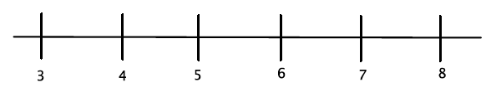
$\sqrt{32} \sqrt{12} \sqrt{27} \sqrt{18} \sqrt{23} \sqrt{50}$

- Between which two integers will $\sqrt{45}$be located? Explain how you know.

