Lesson 4: Simplifying Square Roots

Classwork
Opening Exercises 1–6
- What does $\sqrt{16}$ equal?  - What does $4×4$ equal?  - Does $\sqrt{16}=\sqrt{4×4}$? | - What does $\sqrt{36}$ equal?  - What does $6×6$ equal?  - Does $\sqrt{36}=\sqrt{6×6}$?
- What does $\sqrt{121}$ equal?  - What does $11×11$ equal?  - Does $\sqrt{121}=\sqrt{11×11}$? | - What does $\sqrt{81}$ equal?  - What does $9×9$ equal?  - Does $\sqrt{81}=\sqrt{9×9}$?
- What is another way to write $\sqrt{20}$? | - What is another way to write $\sqrt{28}$?

Example 1
Simplify the square root as much as possible.
$\sqrt{50}=$

Example 2
Simplify the square root as much as possible.
$\sqrt{28}=$

Exercises 7–10
Simplify the square roots as much as possible.
- $\sqrt{18}$

- $\sqrt{44}$

- $\sqrt{169}$

- $\sqrt{75}$

Example 3
Simplify the square root as much as possible.
$\sqrt{128}=$

Example 4
Simplify the square root as much as possible.
$\sqrt{288}=$

Exercises 11–14
- Simplify $\sqrt{108}$.

- Simplify $\sqrt{250}$.

- Simplify $\sqrt{200}$.

- Simplify $\sqrt{504.}$

Problem Set
Lesson Summary
Square roots of non-perfect squares can be simplified by using the factors of the number. Any perfect square factors of a number can be simplified.
For example:
$$\sqrt{72}=\sqrt{36×2} \\ =\sqrt{36}×\sqrt{2} \\ =\sqrt{6^{2}}×\sqrt{2} \\ =6×\sqrt{2} \\ =6\sqrt{2}$$

Simplify each of the square roots in Problems 1–5 as much as possible.
- $\sqrt{98}$

- $\sqrt{54}$

- $\sqrt{144}$

- $\sqrt{512}$

- $\sqrt{756}$

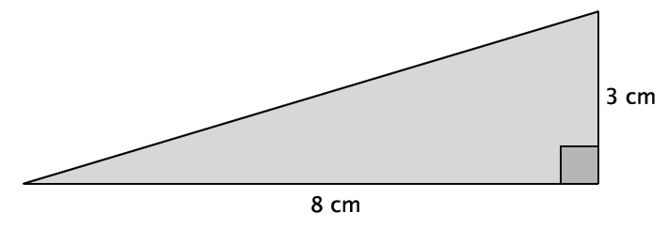
- What is the length of the unknown side of the right triangle? Simplify your answer.

- What is the length of the unknown side of the right triangle? Simplify your answer.
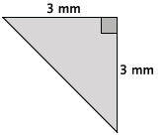

- What is the length of the unknown side of the right triangle? Simplify your answer.
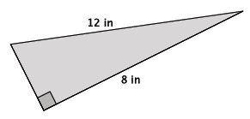

- Josue simplified $\sqrt{450}$ as $15\sqrt{2}$. Is he correct? Explain why or why not.

- Tiah was absent from school the day that you learned how to simplify a square root. Using $\sqrt{360}$, write Tiah an explanation for simplifying square roots.

