Lesson 5: Solving Radical Equations

Classwork
Example 1
Find the positive value of $x$ that makes the equation true.
$$x^{3}+9x=\frac{1}{2}\left(18x+54\right)$$

Example 2
Find the positive value of $x$ that makes the equation true.
$$x\left(x-3\right)-51=-3x+13$$

Exercises 1–8
Find the positive value of $x$ that makes each equation true, and then verify your solution is correct.
- Solve $x^{2}-14=5x+67-5x.$

Explain how you solved the equation.

- Solve and simplify: $x\left(x-1\right)=121-x$.

- A square has a side length of $3x$ and an area of $324$ in². What is the value of $x$?

- $-3x^{3}+14=-67$

- $x\left(x+4\right)-3=4\left(x+19.5\right)$

- $216+x=x\left(x^{2}-5\right)+6x$

- What are we trying to determine in the diagram below?

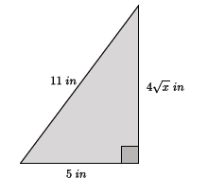

Determine the value of $x$ and check your answer.

Lesson Summary
Equations that contain variables that are squared or cubed can be solved using the properties of equality and the definition of square and cube roots.
Simplify an equation until it is in the form of $x^{2}=p$ or $x^{3}=p$ where $p$ is a positive rational number, then take the square or cube root to determine the positive value of $x.$
Example:
Solve for $x.$  $$\frac{1}{2}\left(2x^{2}+10\right)=30 \\ x^{2}+5=30 \\ x^{2}+5-5=30-5 \\ x^{2}=25 \\ \sqrt{x^{2}}=\sqrt{25} \\ x=5$$ | Check:  $$\frac{1}{2}\left(2{\left(5\right)}^{2}+10\right)=30 \\ \frac{1}{2}\left(2\left(25\right)+10\right)=30 \\ \frac{1}{2}\left(50+10\right)=30 \\ \frac{1}{2}\left(60\right)=30 \\ 30=30$$

Problem Set

Find the positive value of $x$ that makes each equation true, and then verify your solution is correct.
- $x^{2}\left(x+7\right)=\frac{1}{2}\left(14x^{2}+16\right)$

- $x^{3}=1,331^{-1}$

- $\frac{x^{9}}{x^{7}}-49=0$. Determine the positive value of $x$ that makes the equation true, and then explain how you solved the equation.

- ${\left(8x\right)}^{2}=1$. Determine the positive value of $x$ that makes the equation true.

- ${\left(9\sqrt{x}\right)}^{2}-43x=76$

- Determine the length of the hypotenuse of the right triangle below.
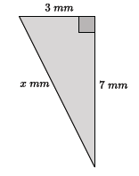
- Determine the length of the legs in the right triangle below.
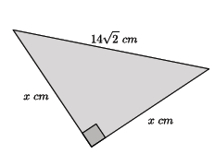

- An equilateral triangle has side lengths of $6$cm. What is the height of the triangle? What is the area of the triangle?
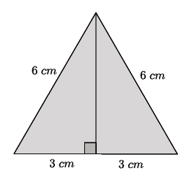

- Challenge: ${\left(\frac{1}{2}x\right)}^{2}-3x=7x+8-10x$. Find the positive value of $x$ that makes the equation true.

- Challenge: $11x+x\left(x-4\right)=7\left(x+9\right)$. Find the positive value of $x$ that makes the equation true.

