Lesson 14: The Decimal Expansion of $π$

Classwork
Opening Exercises 1–3
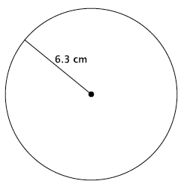
- Write an equation for the area, $A$, of the circle shown.

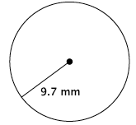
- Write an equation for the circumference, $C$, of the circle shown.

- Each of the squares in the grid below has an area of $1$ unit².
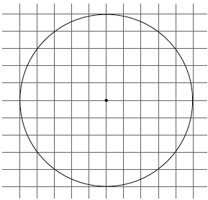

  - Estimate the area of the circle shown by counting squares.

  - Calculate the area of the circle using a radius of $5$ units and $3.14$ for $π$.

Exercises 4–7
- Gerald and Sarah are building a wheel with a radius of $6.5$cm and are trying to determine the circumference. Gerald says, “Because $6.5×2×3.14=40.82$, the circumference is $40.82$cm.” Sarah says, “Because $6.5×2×3.10=40.3$ and $6.5×2×3.21=41.73$, the circumference is somewhere between $40.3$ and $41.73$.” Explain the thinking of each student.

- Estimate the value of the irrational number ${(6.12486…)}^{2}$.

- Estimate the value of the irrational number ${(9.204107…)}^{2}$.

- Estimate the value of the irrational number ${(4.014325…)}^{2}$.

Lesson Summary
Irrational numbers, such as $π$, are frequently approximated in order to compute with them. Common approximations for $π$ are $3.14$ and $\frac{22}{7}$. It should be understood that using an approximate value of an irrational number for computations produces an answer that is accurate to only the first few decimal digits.
Problem Set

- Caitlin estimated $π$ to be $3.10<π<3.21$. If she uses this approximation of $π$ to determine the area of a circle with a radius of $5$cm, what could the area be?

- Myka estimated the circumference of a circle with a radius of $4.5$ in. to be $28.44$in. What approximate value of $π$ did she use? Is it an acceptable approximation of $π$? Explain.

- A length of ribbon is being cut to decorate a cylindrical cookie jar. The ribbon must be cut to a length that stretches the length of the circumference of the jar. There is only enough ribbon to make one cut. When approximating $π$ to calculate the circumference of the jar, which number in the interval $3.10<π<3.21$ should be used? Explain.

- Estimate the value of the irrational number ${(1.86211…)}^{2}$.

- Estimate the value of the irrational number ${(5.9035687…)}^{2}$.

- Estimate the value of the irrational number ${(12.30791…)}^{2}$.

- Estimate the value of the irrational number ${\left(0.6289731…\right)}^{2}$.

- Estimate the value of the irrational number ${\left(1.112223333…\right)}^{2}$.

- Which number is a better estimate for $π$, $\frac{22}{7}$ or $3.14$? Explain.

- To how many decimal digits can you correctly estimate the value of the irrational number ${\left(4.56789012…\right)}^{2}$?

