Lesson 7: Infinite Decimals

Classwork
Opening Exercises 1–4
- Write the expanded form of the decimal $0.3765$ using powers of $10$.

- Write the expanded form of the decimal $0.3333333…$ using powers of $10$.

- What is an infinite decimal? Give an example.

- Do you think it is acceptable to write that $1=0.99999…$? Why or why not?

Example 1
The number $0.253$ on the number line:
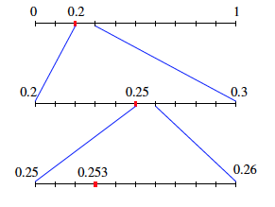
Example 2
The number $\frac{5}{6}=0.833333…=0.8\overline{3}$ on the number line:
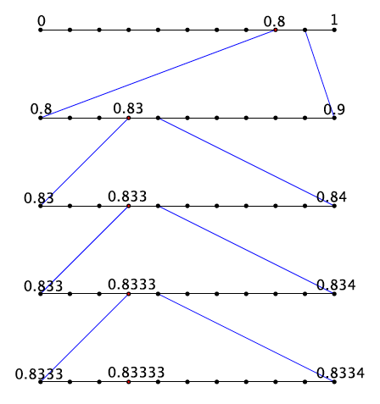

Exercises 5–10
- a. Write the expanded form of the decimal $0.125$ using powers of $10$.

  - Show on the number line the representation of the decimal $0.125$.
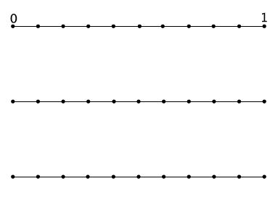
  - Is the decimal finite or infinite? How do you know?

- a. Write the expanded form of the decimal $0.3875$ using powers of $10$.

  - Show on the number line the representation of the decimal $0.3875$.
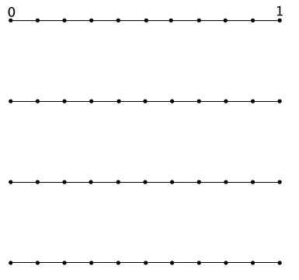

  - Is the decimal finite or infinite? How do you know?

- a. Write the expanded form of the decimal $0.777777…$using powers of $10$.

  - Show on the number line the representation of the decimal $0.777777…$.
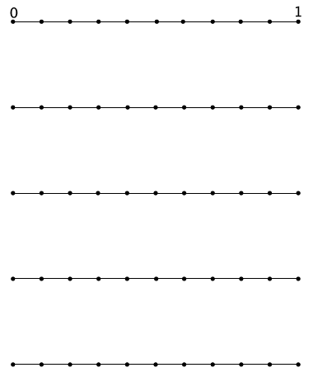
  - Is the decimal finite or infinite? How do you know?

- a. Write the expanded form of the decimal $0.\overline{45}$using powers of $10$.

  - Show on the number line the representation of the decimal $0.\overline{45}$.

  - Is the decimal finite or infinite? How do you know?

- Order the following numbers from least to greatest: $2.121212$, $2.1$, $2.2$, and $2.\overline{12}.$

- Explain how you knew which order to put the numbers in.

Lesson Summary
An infinite decimal is a decimal whose expanded form and number line representation are infinite.
Example:
The expanded form of the decimal $0.83333…$ is $0.8\overline{3}=\frac{8}{10}+\frac{3}{{10}^{2}}+\frac{3}{{10}^{3}}+\frac{3}{{10}^{4}}+…$
The number is represented on the number line shown below. Each new line is a magnification of the interval shown above it. For example, the first line is the unit from $0$ to $1$ divided into $10$ equal parts, or tenths. The second line is the interval from$0.8$to $0.9$ divided into ten equal parts, or hundredths. The third line is the interval from $0.83$ to $0.84$ divided into ten equal parts, or thousandths, and so on.
With each new line we are representing an increasingly smaller value of the number, so small that the amount approaches a value of 0. Consider the $20$^{th} line of the picture above. We would be adding $\frac{3}{{10}^{20}}$ to the value of the number, which is $0.00000000000000000003$. It should be clear that $\frac{3}{{10}^{20}}$ is a very small number and is fairly close to a value of $0$.
This reasoning is what we use to explain why the value of the infinite decimal $0.\overline{9}$ is $1$.

Problem Set
- a. Write the expanded form of the decimal $0.625$ using powers
of $10$.
  - Show the representation of the decimal $0.625$ on the number line.
  - Is the decimal finite or infinite? How do you know?

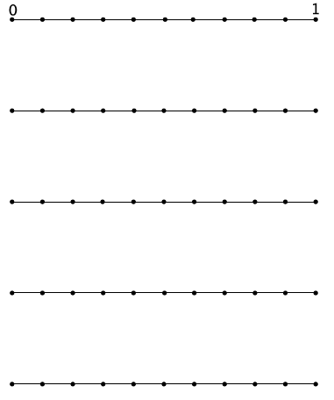
- a. Write the expanded form of the decimal $0.\overline{370}$using powers
of $10$.
  - Show on the number line the representation of the decimal $0.370370…$
  - Is the decimal finite or infinite? How do you know?

- Which is a more accurate representation of the number $\frac{2}{3}:$ $0.6666$ or $0.\overline{6}$? Explain. Which would you prefer to compute with?

- Explain why we shorten infinite decimals to finite decimals to perform operations. Explain the effect of shortening an infinite decimal on our answers.

- A classmate missed the discussion about why $0.\overline{9}=1.$ Convince your classmate that this equality is true.

- Explain why $0.3333<0.33333.$

