Lesson 17: Distance on the Coordinate Plane

Classwork
Example 1
What is the distance between the two points $A$,$B$ on the coordinate plane?
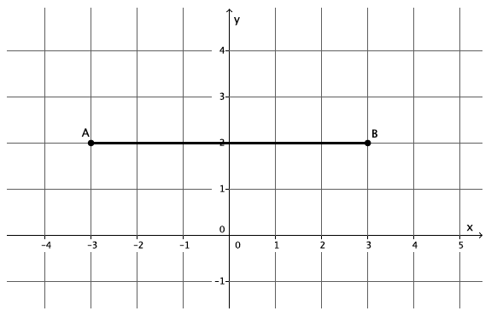

What is the distance between the two points $A, B$ on the coordinate plane?

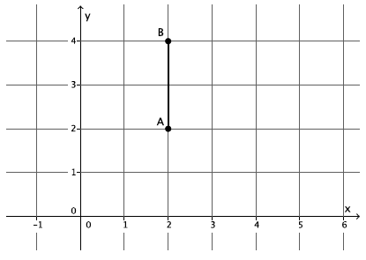

What is the distance between the two points $A$,$B$ on the coordinate plane? Round your answer to the tenths place.
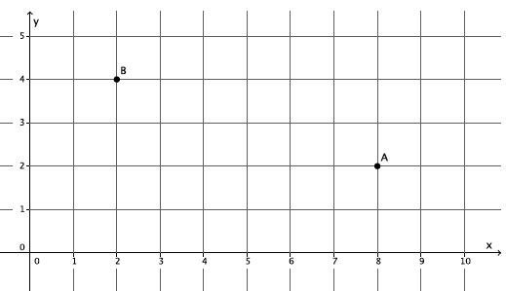

Example 2
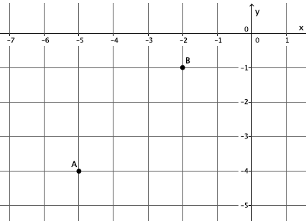

Exercises 1–4
For each of the Exercises 1–4, determine the distance between points $A$ and $B$ on the coordinate plane. Round your answer to the tenths place.

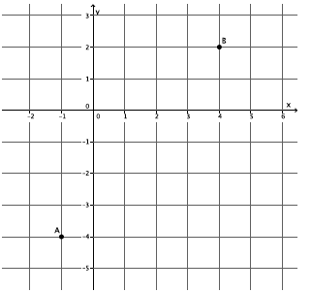

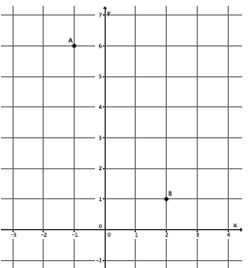

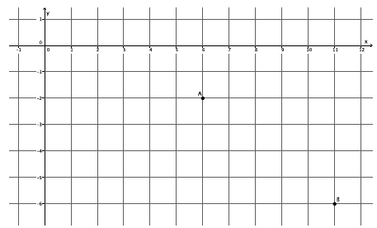

Example 3
Is the triangle formed by the points $A$, $B$,$C$ a right triangle?
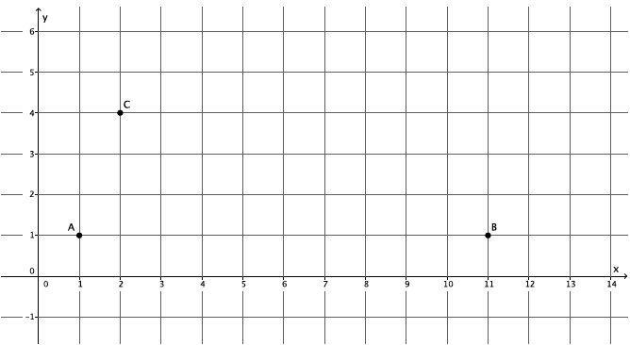

Problem Set
Lesson Summary
To determine the distance between two points on the coordinate plane, begin by connecting the two points. Then draw a vertical line through one of the points and a horizontal line through the other point. The intersection of the vertical and horizontal lines forms a right triangle to which the Pythagorean Theorem can be applied.
To verify if a triangle is a right triangle, use the converse of the Pythagorean Theorem.
For each of the Problems 1–4 determine the distance between points $A$ and $B$ on the coordinate plane. Round your answer to the tenths place.

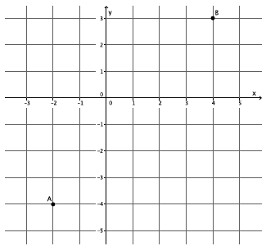

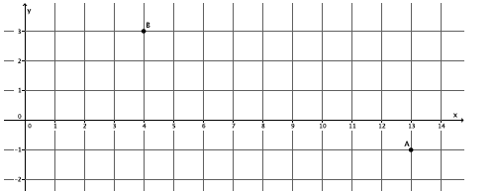

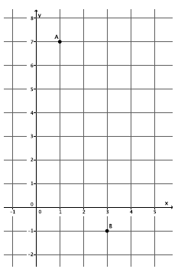

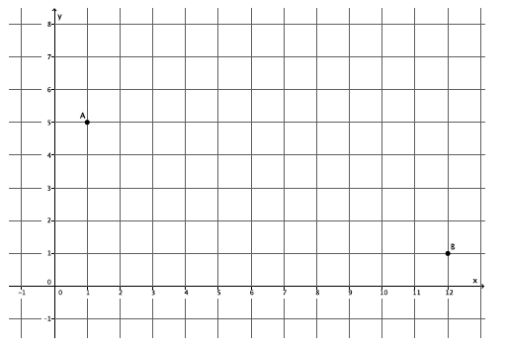

- Is the triangle formed by points $A$,$B$,$C$ a right triangle?

