Lesson 23: Nonlinear Motion

Classwork
Exercise
A ladder of length $L$ ft. leaning against a wall is sliding down. The ladder starts off being flush (right up against) with the wall. The top of the ladder slides down the vertical wall at a constant speed of $v$ ft. per second. Let the ladder in the position $L_{1}$ slide down to position $L_{2}$ after $1$ second, as shown below.
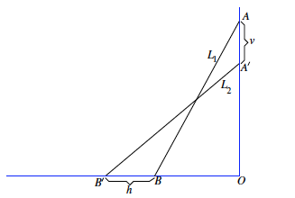

Will the bottom of the ladder move at a constant rate away from point $O$?
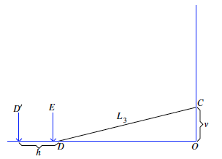
Consider the three right triangles shown below. Specifically the change in the length of the base as the height decreases in increments of $1$ ft.
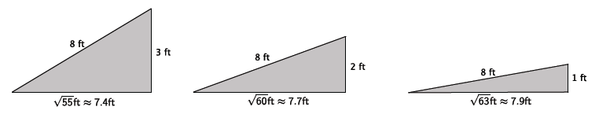

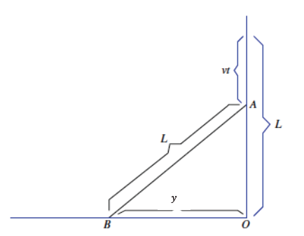
Input  $$t$$ | Output  $$y=\sqrt{t(30-t)}$$
$$0$$
$$1$$
$$3$$
$$4$$
$$7$$
$$8$$
$$14$$
$$15$$
Problem Set

- Suppose the ladder is $10$ feet long, and the top of the ladder is sliding down the wall at a rate of $0.8$ ft. per second. Compute the average rate of change in the position of the bottom of the ladder over the intervals of time from $0$ to $0.5$ seconds, $3$ to $3.5$ seconds, $7$ to $7.5$ seconds, $9.5$ to $10$ seconds, and $12$ to $12.5$ seconds. How do you interpret these numbers?

Input  $$t$$ | Output  $$y=\sqrt{0.8t(20-0.8t)}$$
$$0$$
$$0.5$$
$$3$$
$$3.5$$
$$7$$
$$7.5$$
$$9.5$$
$$10$$
$$12$$
$$12.5$$

- Will any length of ladder, $L$, and any constant speed of sliding of the top of the ladder $v$ ft. per second, ever produce a constant rate of change in the position of the bottom of the ladder? Explain.

