Lesson 13: Comparison of Numbers Written in Scientific Notation and Interpreting Scientific Notation Using Technology

Classwork
There is a general principle that underlies the comparison of two numbers in scientific notation: Reduce everything to whole numbers if possible. To this end, we recall two basic facts.
- Inequality (A) in Lesson 7: Let $x$ and $y$be numbers and let $z>0$. Then $x<y$ if and only if $xz<yz$.
- Comparison of whole numbers:
  - If two whole numbers have different numbers of digits, then the one with more digits is greater.
  - Suppose two whole numbers $p$and $q$ have the same number of digits and, moreover, they agree digit-by-digit (starting from the left) until the $n$^{th} place. If the digit of $p$ in the $(n+1)$^{th} place is greater than the corresponding digit in $q$, then $p>q$.

Exercise 1
The Fornax Dwarf galaxy is $4.6×{10}^{5}$ light-years away from Earth, while Andromeda I is $2.430×{10}^{6}$ light-years away from Earth. Which is closer to Earth?

Exercise 2
The average lifetime of the tau lepton is $2.906×{10}^{-13}$ seconds, and the average lifetime of the neutral pion is $8.4×{10}^{-17}$ seconds. Explain which subatomic particle has a longer average lifetime.

Exploratory Challenge 1/Exercise 3
Theorem: Given two numbers in scientific notation, $a×{10}^{m}$ and $b×{10}^{n}$, if $m<n$, then $a×{10}^{m}<b×{10}^{n}$.

Prove the theorem.

Exercise 4
Compare $9.3×{10}^{28}$ and $9.2879×{10}^{28}$.

Exercise 5
Chris said that $5.3×{10}^{41}<5.301×{10}^{41}$ because $5.3$ has fewer digits than $5.301$. Show that even though his answer is correct, his reasoning is flawed. Show him an example to illustrate that his reasoning would result in an incorrect answer. Explain.

Exploratory Challenge 2/Exercise 6
You have been asked to determine the exact number of Google searches that are made each year. The only information you are provided is that there are $35,939,938,877$searches performed each week. Assuming the exact same number of searches is performed each week for the $52$ weeks in a year, how many total searches will have been performed in one year? Your calculator does not display enough digits to get the exact answer. Therefore, you must break down the problem into smaller parts. Remember, you cannot approximate an answer because you need to find an exact answer. Use the screen shots below to help you reach your answer.

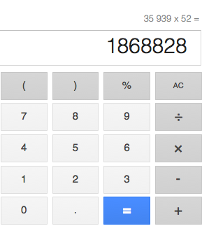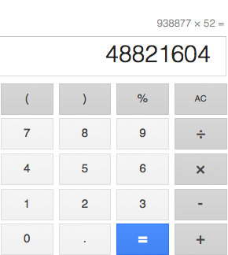

Yahoo is another popular search engine. Yahoo receives requests for $1,792,671,355$ searches each month. Assuming the same number of searches is performed each month, how many searches are performed on Yahoo each year? Use the screen shots below to help determine the answer.
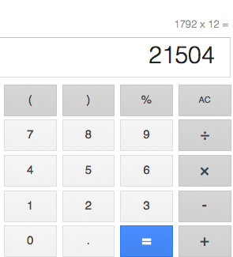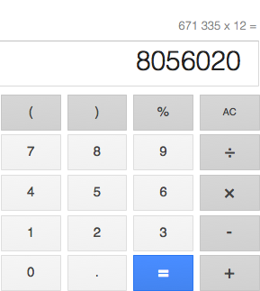

Problem Set

- Write out a detailed proof of the fact that, given two numbers in scientific notation, $a×{10}^{n}$ and $b×{10}^{n}$, $a<b$, if and only if $a×{10}^{n}<b×{10}^{n}$.
  - Let $A$ and $B$ be two positive numbers, with no restrictions on their size. Is it true that $A×{10}^{-5}<B×{10}^{5}$?
  - Now, if $A×{10}^{-5}$ and $B×{10}^{5}$ are written in scientific notation, is it true that $A×{10}^{-5}<B×{10}^{5}$? Explain.

- The mass of a neutron is approximately $1.674927×{10}^{-27}$ kg. Recall that the mass of a proton is
$1.672622×{10}^{-27}$ kg. Explain which is heavier.

- The average lifetime of the Z boson is approximately $3×{10}^{-25}$ seconds, and the average lifetime of a neutral rho meson is approximately $4.5×{10}^{-24}$ seconds.
  - Without using the theorem from today’s lesson, explain why the neutral rho meson has a longer average lifetime.
  - Approximately how much longer is the lifetime of a neutral rho meson than a Z boson?

